Facial Anatomy

Indications and Facial assessment

Dysport 50 units

Restylane or Perlane

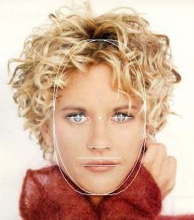
Beauty is characterized by:

- A youthful face

- Symmetry and harmony

- Clear skin

- Even skin tone and texture

- Attractive smooth lips

http://www.phimatrix.com/face.htm downloaded on 29/11/12

Facial aging

Causes of ageing

Intrinsic factors
- Genetics
- Gender
- Time
- Evolution
- Expressivity
- Atrophy of dermis and subcutaneous tissue
Clinical signs
- Wrinkles
- Laxity
- 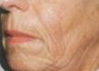Atrophy
- Volume loss

Extrinsic factors
- Smoking
- Sun exposure

Affected structures
- Collagen
- Elastin fibres
- Fibroblasts and matrix

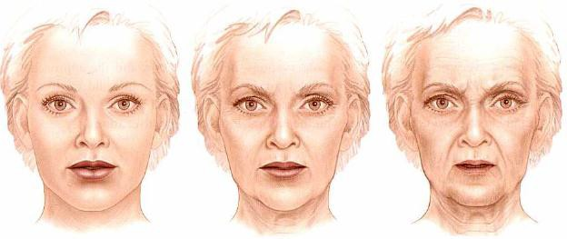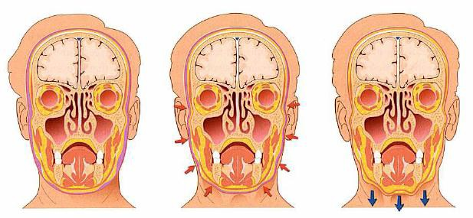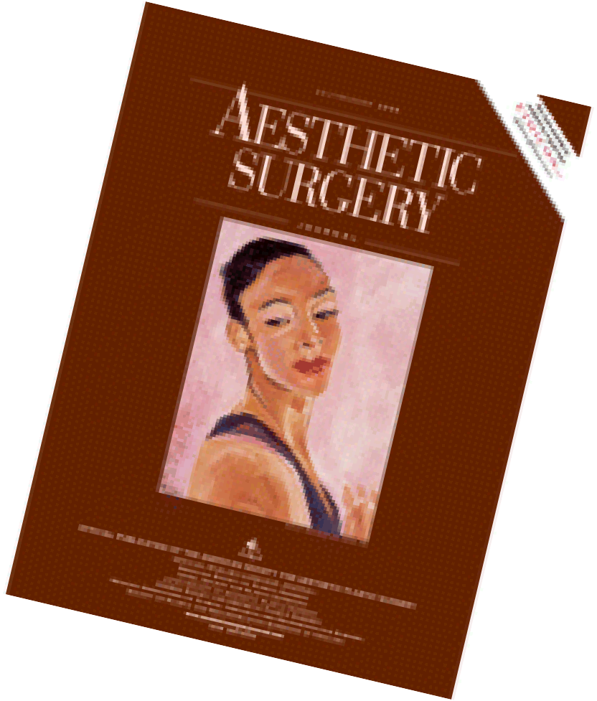Ageing Face = Volume loss

Rajiv Grover & Sydney Coleman 2006 American Journal of Aesthetic Surgery

Facial fat compartments

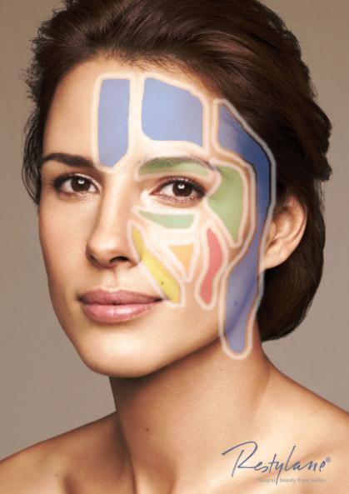
The knowledge of anatomy
provides a better understanding and greater precision for the analysis and development of facial ageing treatments.

ANATOMICAL CONSIDERATIONS

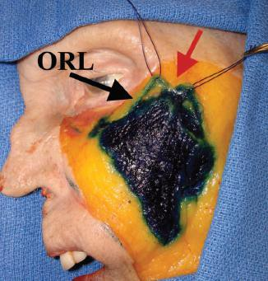
Cheek fat compartments
Three different cheek fat areas: temporal-medial,
middle and lateral-temporal
a) Medial compartment:
This area is outlined outside by the ORL ligament and the orbital area.

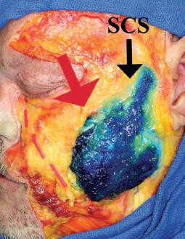
b) Middle portion of the compartment:
This fat compartment is anterior and superficial to the parotid gland.
At the top it is attached to the zygomatic major
muscle.
The upper edge is defined by the top wall of the cheek (SCS).

Naso-labial Fat Compartment

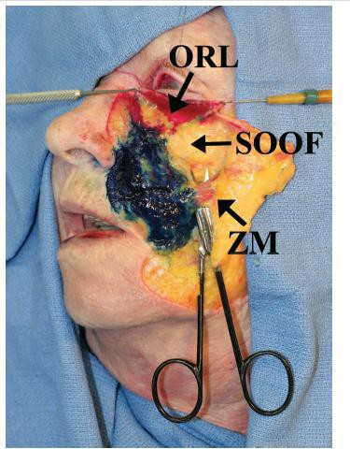
The naso-labial fat area is the middle of the cheek
area

- The outer limit is the orbicular retaining ligament (ORL).

- The suborbicular (SOOF) is the lateral and deep
limit

- The inferior edge is the zygomaticus major muscle (ZM) , the muscle that is attached to this compartment.

(Plast. Reconstr. Surg. 119: 2219, 2007.)

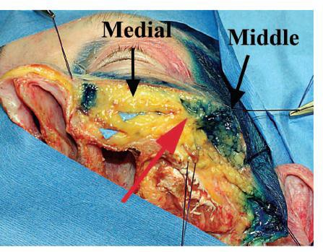

Transversal anatomical section shows 3 confluent areas, and they form a dense
zone(red arrow)

The zygomaticus muscle is found at the deepest when it is at this crossover level

Facial nerves

Sensory innervation of the face

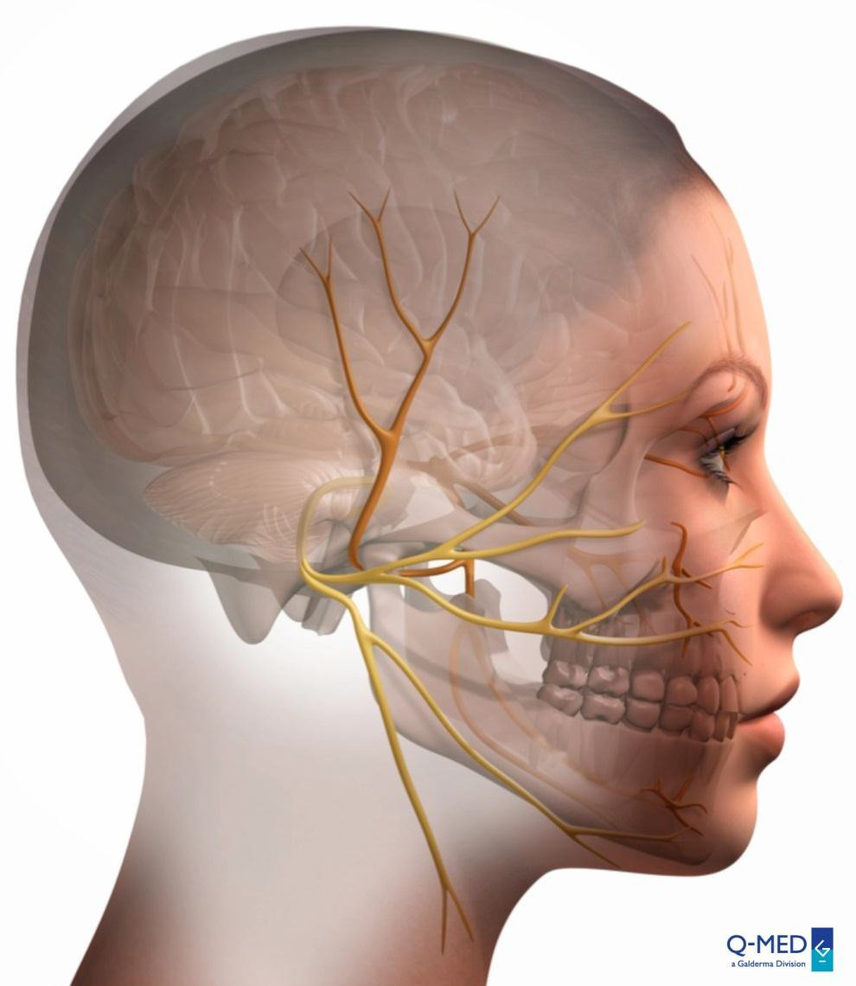Trigeminal nerve
CN V

Supratrochlear Supraorbital
CN V1
Lacrimal Zygomaticotemporal
Zygomaticofacial
CN V2
Infra orbital Facial

Auriculotemporal Buccal
CN V3
Mental

http://www.davidson.edu/academic/psychology/ramirezsite/neuroscience/psy324/aa
patton/anatom4.jpg

DANGER ZONES FACIAL NERVES

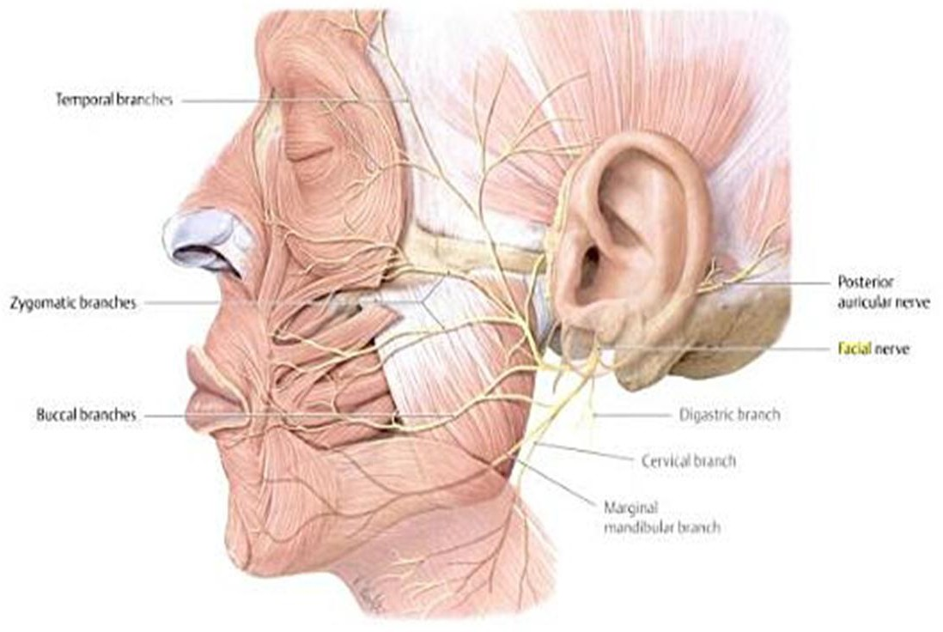

Micahel Schuencke et al, Thieme Atlas of Anatomy Head and Neuroanatomy New York USA 2010

DANGER ZONES FACIAL NERVES
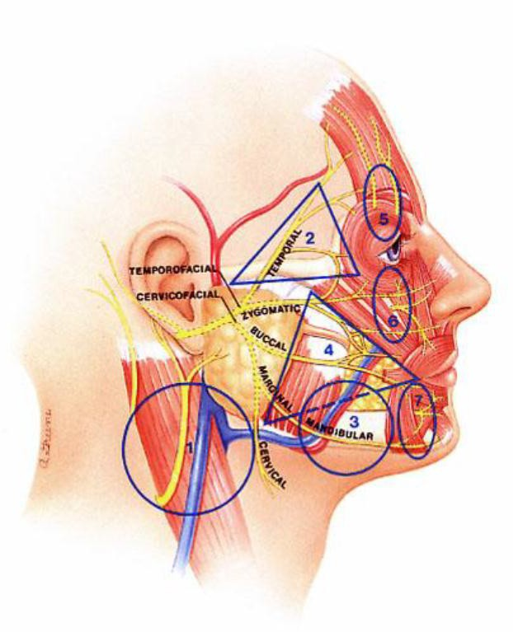
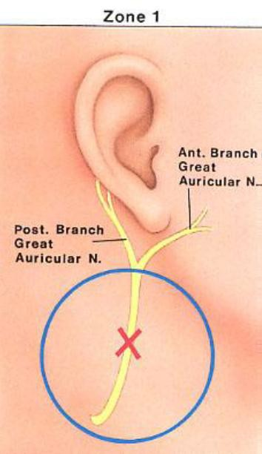

http://avshalom-shalom.com/interns/face%20lift/facial%20anatomy.pdf downloaded 26 March 2013 @11.40am

DANGER ZONES FACIAL NERVES

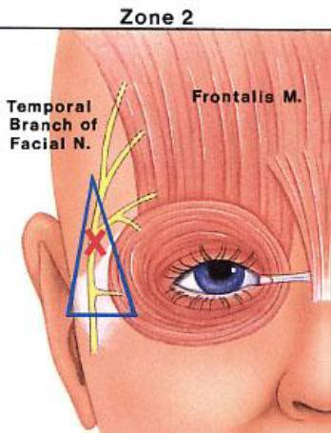
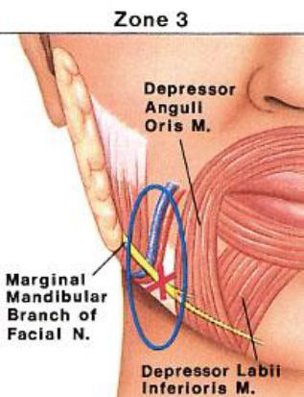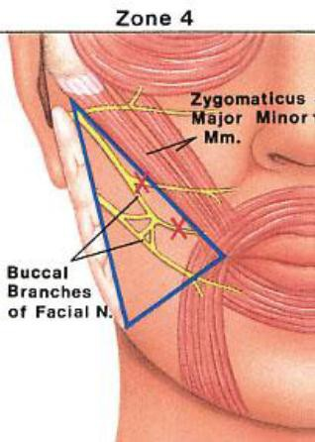

http://avshalom-shalom.com/interns/face%20lift/facial%20anatomy.pdf downloaded 26 March 2013 @11.40am

DANGER ZONES FACIAL NERVES

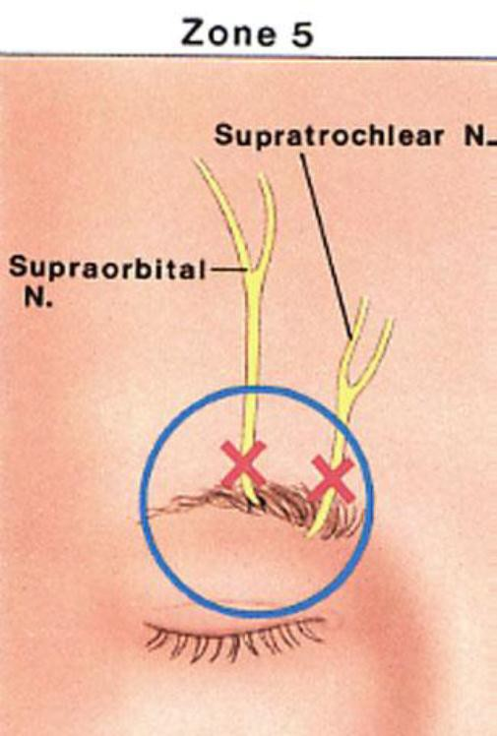
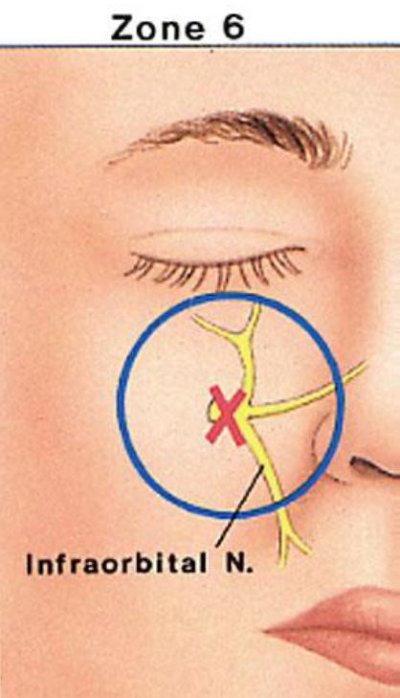
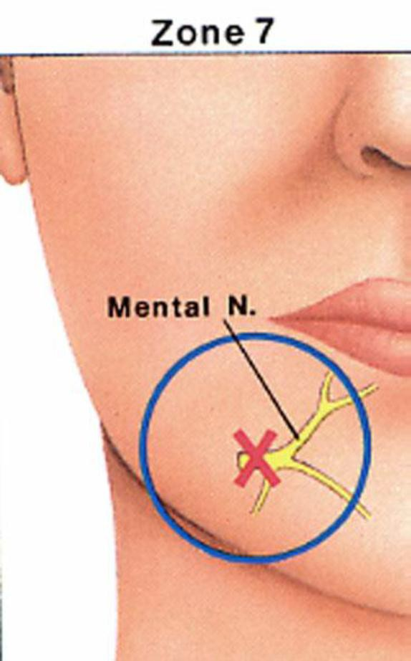

http://avshalom-shalom.com/interns/face%20lift/facial%20anatomy.pdf downloaded 26 March 2013 @11.40am

Blood supply of the face

Arterial blood supply of the face

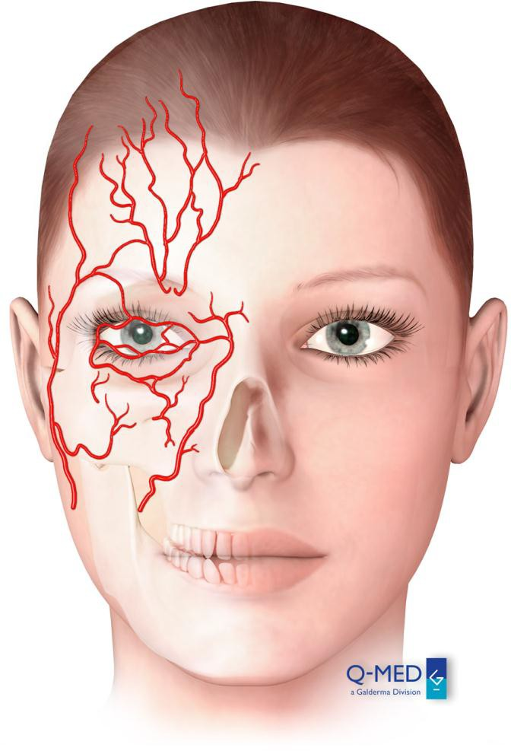Supraorbital

Supratrochlear

Temporal artery

Lacrimal Lateral nasal

Angular Infraorbital Transverse facial

Facial

DANGER ZONES FACIAL ARTERIES

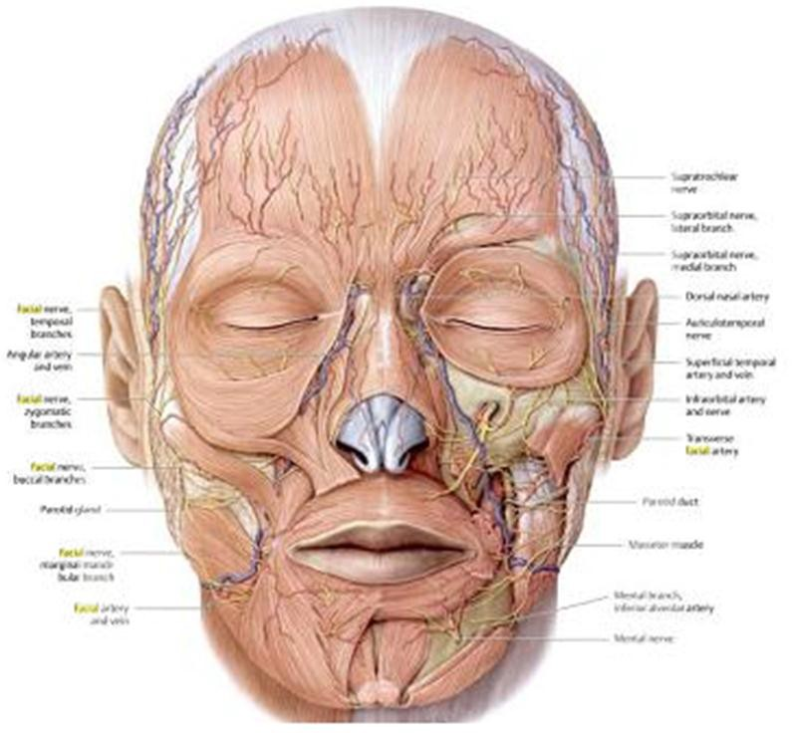

Micahel Schuencke et al, Thieme Atlas of Anatomy Head and Neuroanatomy New York USA 2010

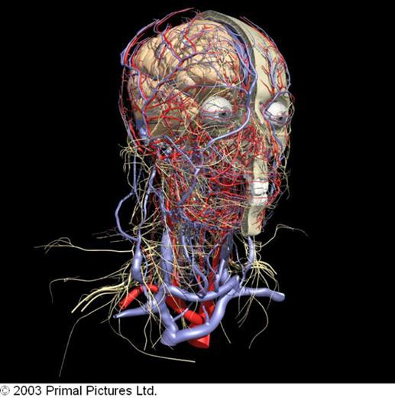

Muscles of the face
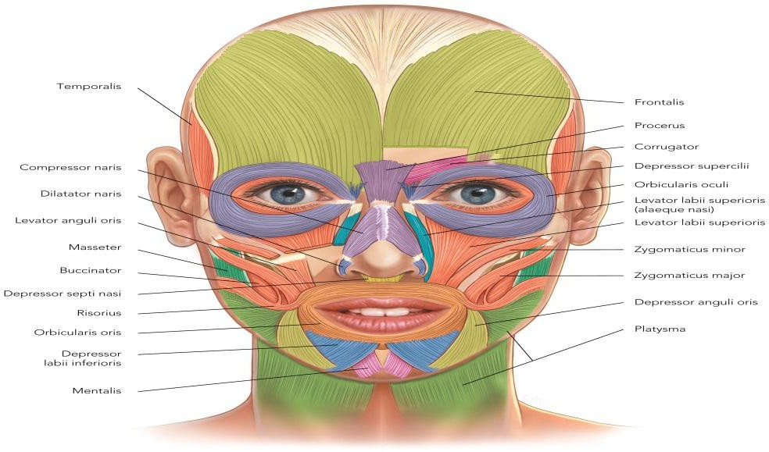

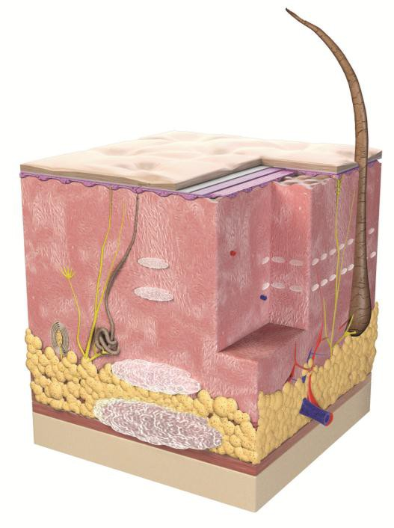
3 COLUMNS OF COSMETIC DERMATOLOGY

AREA OF CLINICAL AGEING | TREATMENT OPTIONS
Skin surface and texture | + Laser and light-based treatments  + Chemical peels  + Medical skin needling  + HA skin revitalisation  + (micro) – dermabrasion  + Tretinoin or cosmeceutical skincare regimens
Volume and  contour loss | + Volumetric restoration/augmentation with injectable soft-tissue volumisers/implants  + Facial contouring/sculpting  + Tissue stimulators
Lines and wrinkles | + Muscle relaxation with botulinum toxin  + Injectable dermal fillers/soft-tissue implants  + Tissue stimulators
Dr Stefanie Williams, The 3D Approach to Cosmetic Dermatology DERMA 2010; 1(2). Sept 2010

Treatment solution with Restylane range

Versatile with a solution for different skin types and indications

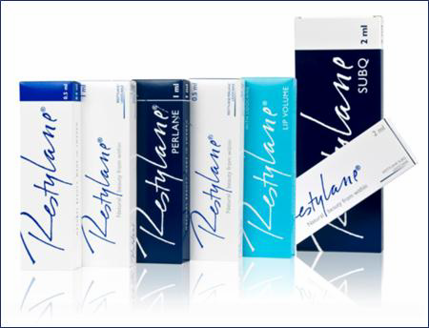

THE RESTYLANE® RANGE

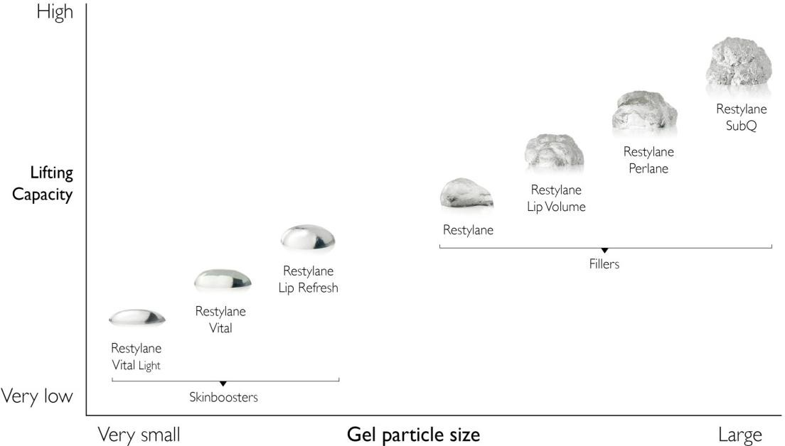+ A solution for different skin types and indications
+ Products can be layered
+ Superior lifting capacity vs other HA products1,2*

*In rheological tests

- Stocks D et al. J Drugs Dermatol 2011;10:974-80. 2. Edsman K et al. Dermatol Surg 2012;38:1170-79. 3. Restylane SubQ IFU. February 2011

The Combination Treatment Concept

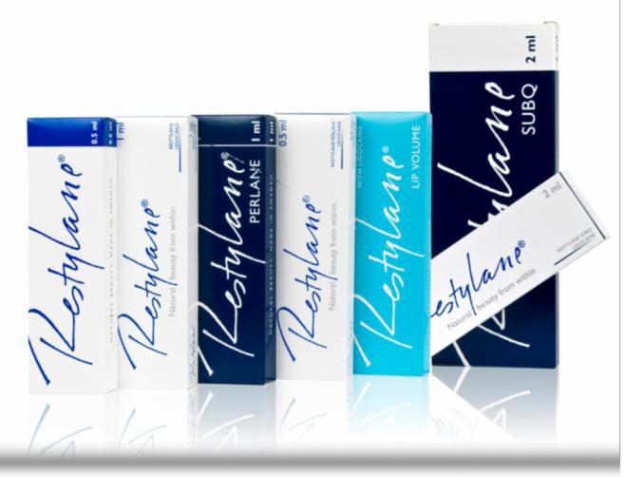NASHA™ fillers

restore facial volume
  - create a more youthful and enhanced facial appearance
Layering of SubQ and Perlane to smooth and lift

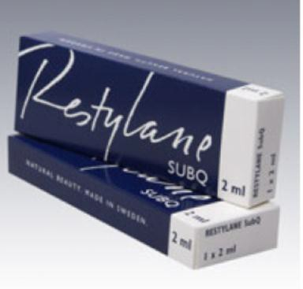
Restylane SubQ

Strongest product in the range – ultimate lifting capacity
  - A niche product
  - 1mL per cheek at single treatment session with a maximum dose of 2mLs
  - Place deeply
  - Perlane can be combined with SubQ to layer
  - Needle or cannula (I prefer Needle - precision, ease and speed)
  - Patient selection
  - Hygiene and Asepsis critical

Q-Med Clinical Guide, SubQ PI

Restylane Perlane

Strongest product when tested against
competitor HAs
  - Strong lifting capacity – high G prime
  - Can be layered together with SubQ
  - Inject into subcutis
  - Needle or cannula (I prefer Needle -
precision, ease and speed)

Superior lifting capacity

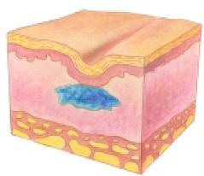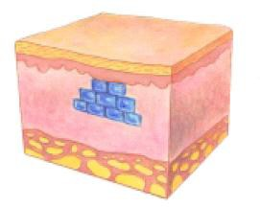

For smooth skin and restored volume

COMBINATION TREATMENT - STEPS

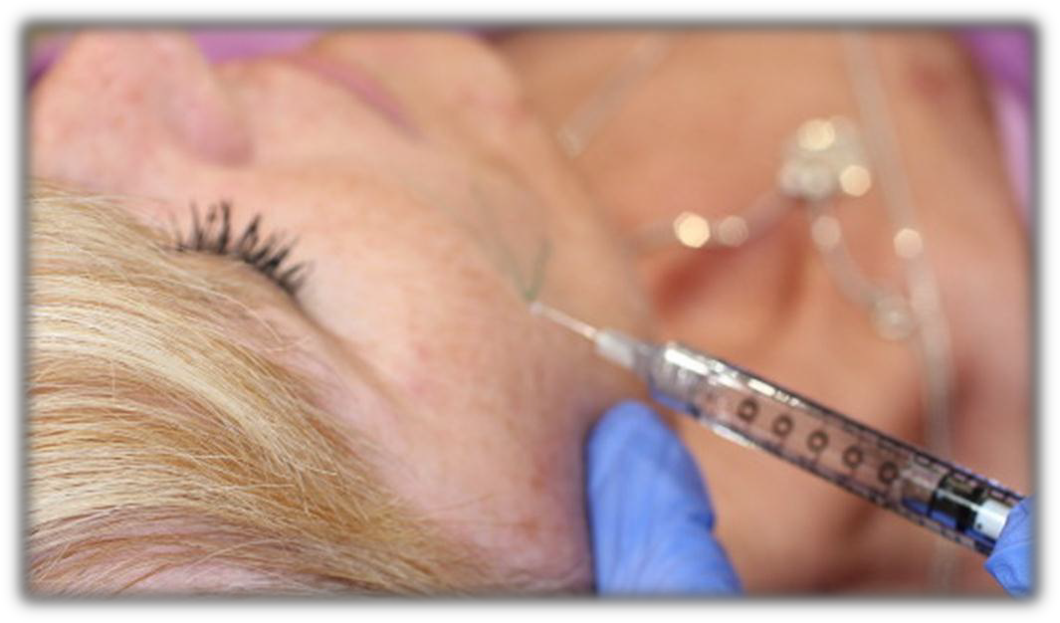
1.Assess 2.Educate 3.Plan
- Treat by indication

- Create ongoing treatment plan

Stocks, D 2010

Key Success Factors – DOCTOR/INJECTOR

Skilled

  - Experienced

  - Trained with volumetrics

  - Good anatomical knowledge

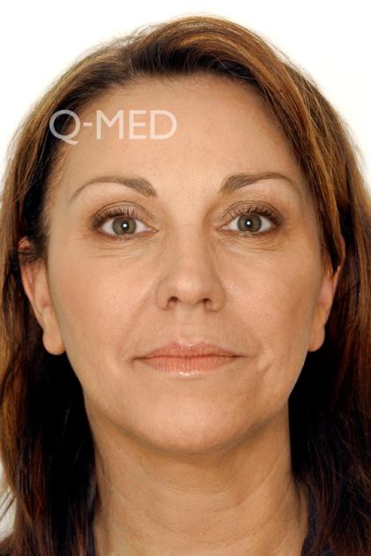
Key Success Factors - PATIENT

Healthy Patient

  - Good soft tissue covering

  - Mild to moderate volume loss

  - Reasonable skin elasticity

  - No infections – sinus, dental, skin or systemic

  - No other products insitu esp. permanent product

- Almost every patient can have versatile Perlane – strong and robust product (Stocks,D et al 2011)

Key Success Factors - TREATMENT

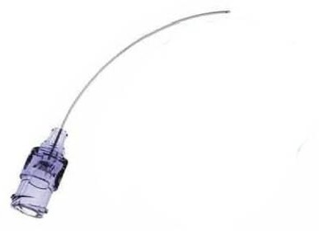Aseptic technique

  - Cannula vs Needle

  - Bolus vs Thread

SUBQ
  - Prophylactic Antibiotics
  - Volumes 1mL per Malar
  - Deep periosteal and deep Sub-Cuticular injection

NEEDLE OR CANNULA?

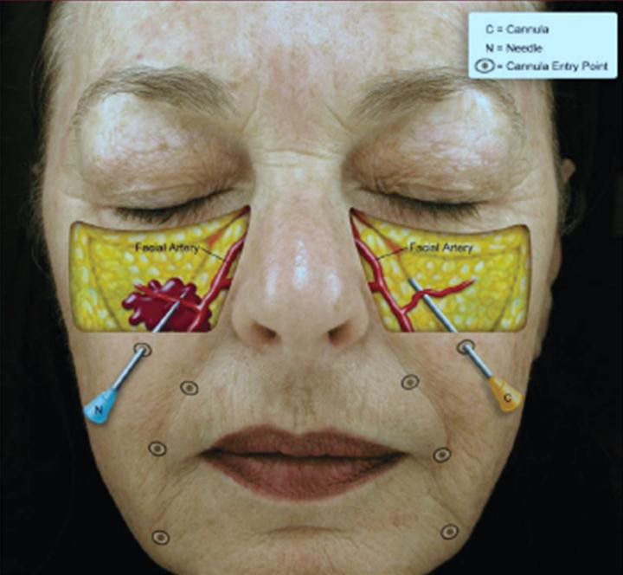
Image courtesy of Maria Kim and Joel L. Cohen MD

Zeichner J.A. and Cohen, J. L. 2012

Transdermal Needle Technique

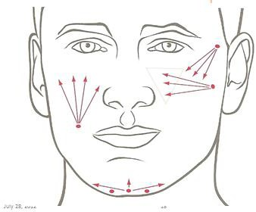

Q-Med Clinical Guide

Managing Complications

  - Early intervention and medical
assessment

  - Appropriate investigations

  - If inflammation suspect infection and treat with appropriate antibiotics (prescribed by doctor)

Benefit of multiple syringe treatment to patient

  - Excellent value

  - Create the WOW effect minimizing
perception of age (Amy Forman Taub)

  - Look good feel good factor

Benefit of multi syringe treatments

  - Allow for individualization of treatment

  - Makes sense financially

  - Multiple syringes reduces perception of
age (Amy Forman Taub)

  - Positive results lead to referrals ( WOW
leads to WORD OF MOUTH)

Best practice

  - Let patients know what you offer

  - Communicate and educate patients

  - Team approach - Involve all staff

  - Follow up

  - Positive patient experiences

Business Pearls

- Promote solutions to patient problems

- Convert, retain and gain referrals from patients (WOW experience)

- Most patients check out issues online first not in clinic

- All staff trained concept being promoted

- Don’t under estimate the competition

- Communicate consistently with patients

Publications

Berros, P. (2010) Periorbital Contour Abnormalities: Hollow Eye Ring Management with Hyaluronstructure. Orbit. 29(2) 119 – 125

Downie, J. et al (2009) A double-blind, clinical evaluation of facial augmentation treatments: comparison of PRI 1, PRI 2, Zyplast and Perlane Journal of Plastic, Reconstructive & Aesthetic Surgery 62; 1636 – 1643

Hirmand, Haideh (2010) Anatomy and Nonsurgical Correction of theTear Trough Deformity PRS Journal 125(2): 699 - 708

Moss, C. J. et al (2000) Surgical Anatomy of the Ligamentous Attachments in the Temple and Periorbital Regions. Plastic and Reconstructive Surgery 105 (4) 1475 – 1490

Stocks, D. et al (2011) Rheological Evaluation of the Physical Properties of Hyaluronic Acid Dermal Fillers. J Drugs Dermatol 10(9):974 - 980

Williams, S. (2010) The 3-D Approach to Cosmetic Dermatology Derma 1: (2) 59 - 66

