April 2014 s35 VOLUME 13 • ISSUE 4
Copyright © 2014 Journal of Drugs in Dermatology

Understanding, Avoiding, and Treating Potential Adverse Events Following the Use of Inj
ectable ial
Poly-L-Lactic Acid for Facial and Nonfac Volumization
Danny Vleggaar MD,a Rebecca Fitzgerald MD,b and Z. Paul Lorenc MD FACSc
aHead of Cosmetic Dermatology in Private Practice, Geneva, Switzerland bDepartment of Medicine, David Geffen School of Medicine, University of California, Los Angeles, Los Angeles, CA, USA cLorenc Aesthetic Plastic Surgery Center, New York, NY, USA
ABSTRACT
Injection-related adverse events (AEs) may occur with the use of any injectable substance, including all commercially available fillers. The most common of these AEs include discomfort, bruising, edema, and erythema, which are generally transient and resolve spontaneously. The majority of AEs widely felt to be associated with poly-L-lactic acid (PLLA) are papules, nodules, and granulomas. Papules and nodules, which are histologically distinct from granulomas, tend to arise several weeks after injection, are generally palpable, asymptomatic, and nonvisible, and will typically resolve on their own, but can be camouflaged with the use of hyaluronic acid. They generally result from suboptimal product reconstitution or placement and, as such, their incidence can be minimized by improved injection methodology. In contrast, true inflammatory granulomas are very rare (incidence 0.01%-0.1%), seem to be systemic in nature, and represent an overabundance of host reaction to PLLA. Granulomas may become apparent months or years post-injection and may persist and grow over time. Their treatment is geared toward halting the increased secretion of interstitial substances and invasion of cells, and may include the administration of steroids and antimetabolites such as 5-fluorouracil.
J Drugs Dermatol. 2014;13(suppl 4):s35-s39.

Introduction

Injection-related adverse events (AEs) may occur with the use of any injectable substance, including all currently commercially available fillers. The most common of these AEs include discomfort, bruising, edema, and erythema, which are generally transient and resolve spontaneously.1-5 Potentially far more serious, and
fortunately far less common, injection-related AEs can also include tissue necrosis, including rare cases of blindness.6,7 This may be caused by inadvertent intravascular injections, and has also been described in the literature with all injectable fillers. The ability to reflux to ensure the needle is not in a vessel prior to injection
of poly- L-lactic acid (PLLA) is technically possible because it is a very low viscosity suspension injected with a large (25 or 26) gauge needle, and thus may offer some advantage. Another potentially injection-related AE described with many injectable fillers, including PLLA, is infection.8 This may highlight the importance of
proper facial cleansing and preparation prior to multiple injection sites with long-lasting fillers. Finally, the majority of AEs widely felt to be associated with PLLA are papules, nodules, and granulomas. These terms have been used interchangeably, although they are, in fact, clinically very distinct. This distinction merits

clarification as it has caused a fair amount of confusion, and will be discussed below.

Papules and Nodules

These are typically palpable, asymptomatic, and nonvisible, tend to arise several weeks after injection, and frequently remain the same size until they are resorbed, treated, or removed. 9 They have been noted to occur more frequently around the hypermobile perioral and periocular regions.10
An incidence rate of 6% to 44% for papules/nodules with the use of PLLA was reported in early studies.2,4,5,11-17 This frequent occurrence may have had a disproportionately large impact on the perception of PLLA safety, as each was classified as a serious AE by regulatory bodies such as the US Food and Drug
Administration.18 Currently, clinical experience has taught us that the occurrence of papules and nodules
stems from suboptimal product reconstitution or placement and can be minimized if proper techniques are implemented during the preparation and injection of PLLA.9,19 Indeed, a review of the literature confirms that these AEs occur infrequently when optimal modalities are used.20 The simple yet critical techniques to
ensure even distribution and proper placement of the implanted PLLA to maximize outcomes and minimize the occurrence of nodules are reviewed in the preceding article of this supplement21 and again in the final article.22
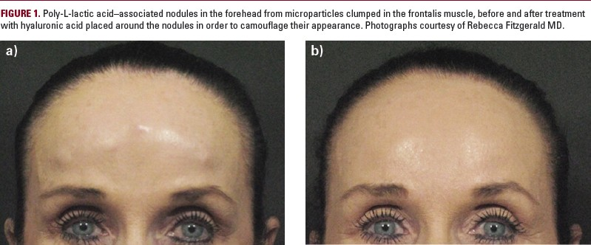

Histologically, papules and nodules consist of an overabundance of microparticles (often surrounded by skeletal muscle) surrounded by a normal foreign body reaction including foreign body giant cells.9 It is important to note that the presence of foreign body giant cells constitutes a histopathological diagnosis of
“granuloma,” initially implicating these lesions to be inflammatory lesions. This implication led to early treatment of this problem with steroid injections. However, injection of steroids or anti-mitotics such as 5- fluorouracil (5-FU) have little clinical effect on these lesions because the majority of the lesion is product and not host reaction to product. Additionally, injection of steroids may lead to atrophy of adjacent tissue, actually accentuating the visibility of the nodule. Most nodules associated with PLLA injection will resolve on their
own.23 Many patients simply need reassurance that they are not dangerous, will not grow in size or number,
and will resolve on their own. Excision is an option, but resolves a transient problem with a permanent scar.23,24 Camouflage of these lesions with hyaluronic acid (HA) gel until they resolve may offer a more gratifying treatment (Figure 1).
"Most nodules associated with poly- L-lactic acid injection will resolve on their own."
Finally, the location of papules and nodules may suggest their origin. Proper dilution, reconstitution, and deep placement are critical. Superficial placement leads to visible papules. Placement in or through active muscles, particularly under the eye or near the corners of the mouth, leads to localized overcorrection and nodules (representing product trapped in muscle fibers). These may even be seen in a patient with a strong zygomaticus major muscle. Diffuse papules/nodules are likely to be an issue with reconstitution (ie, shaking the vial immediately after adding water; crystals on the sidewalls of the vial won’t hydrate), inadequate hydration time (leading to in vivo hydration), or poor suspension immediately prior to injection (leading to

uneven distribution of particles). Lastly, focal papules/nodules may be an issue of placement (ie, redeposition at the apex of a “fan” when using the fanning technique).

Granulomas

First, it should be noted that the term “granuloma” has been used in reference to papules and nodules as well as to large inflammatory lesions in the medical literature,3 which has resulted in considerable challenges in the interpretation of granuloma incidence and, in turn, to the overall safety profile associated with the use of
injectable products such as PLLA.3 In contrast to the low power histopathology of a nodule showing an
overabundance of product with a “normal” foreign body reaction consisting of a few foreign body giant cells, histopathology of a true granuloma shows a smaller amount of product with an overabundance of host reaction to product and “wall-to-wall” foreign body giant cells (Figure 2).19 This is in contrast to the purposeful
stimulation of a subclinical inflammation, which is, in fact, the mechanism of action of stimulatory products like PLLA, calcium hydroxyapatite, and polymethylmethacrylate. With the injection of collagen stimulators in a normal host, subclinical granulomatous inflammation is a natural and desired tissue response that follows a
predictable course.19 A form of chronic inflammation, granulomatous inflammation occurs to prevent the
migration of bodies that cannot be removed by phagocytosis or enzymatic breakdown; it is histologically distinctive for its accumulation of epithelioid cells, a type of modified macrophage.3 In a “normal” response, the encapsulation of the product and the subsequent fibroplasia is
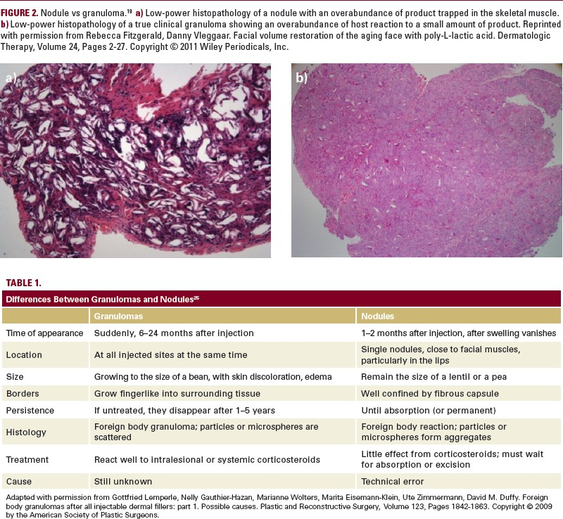

predictable in amount and volumizes the tissue to produce the desired cosmetic result.

Lemperle et al25 have tabulated some well-defined clinical differences between true inflammatory granulomatous reactions and papules/nodules (Table 1).25 The most striking clinical difference is that a true granulomatous reaction seems to be a systemic response (ie, the reaction is seen in all treated areas at the
same time). In contrast to nodules, granulomas may become apparent months or years post-injection9 (Table
1). They typically have poorly defined borders and may persist and grow over time, although they too are capable of spontaneous resolution.9
All injectable dermal fillers have the potential, in some patients, to cause a foreign body–type reaction that may develop into a granuloma.19,24,26 However, the incidence of visible, clinically significant granulomas with injectables, including PLLA, in actual clinical practice is very low (0.01%–0.1%),3,27,28 and their occurrence is currently unpredictable.19 A recent review of the literature and new case reports summarized the clinical features of 56 biomaterial- induced granulomas involving oral and perioral tissues and is shown in Table 2.28
In this review, there were 4 reports of granulomas with PLLA use, less than the number reported with
silicone, collagen, HA, and acrylic hydrogel suspended in HA; however, this may reflect which of these fillers is most commonly used.28
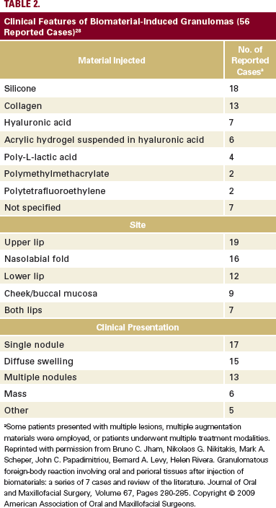

In the treatment of granulomas, surgical excision is not recommended due to their poorly defined borders and the potential for this approach to lead to fistulas, abscesses, or scars.9 Treatment is geared toward stopping both the increased secretion of interstitial substances and the invasion of cells.24 Approaches include the
administration of steroids (intralesional, intramuscular, or systemic) with or without the coadministration of immune-modulating medications.9 Intralesionally injected 5-fluorouracil, alone or in combination with triamcinolone acetonide or betamethasone, are among other approaches demonstrated to be highly effective
(Table 324; Figure 3). In addition, intense pulsed light can be a useful adjunct for the treatment of engorged
capillaries.9 Recurrence following the successful treatment and resolution of granulomas is rare.9
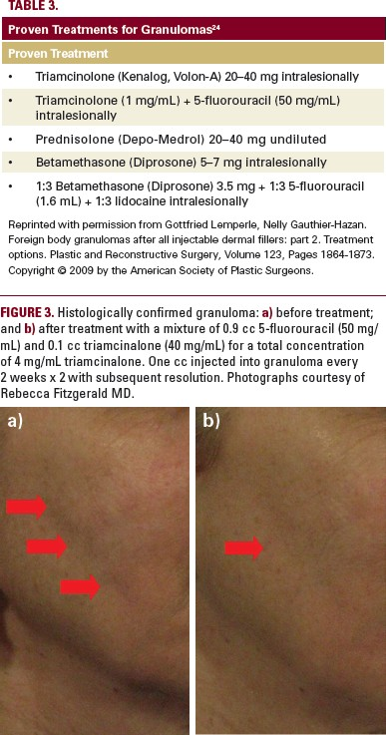

SUMMARY
Injection-related AEs with the use of PLLA are generally transient and typically resolve spontaneously. Most patients simply need reassurance that the AEs will resolve on their own. To summarize simply, papules and nodules represent an overabundance of product with a predictable host reaction and granulomas represent a profound overabundance of host reaction to product. The occurrence of nodules, which are generally nonvisible and asymptomatic, has been minimized through improved methodology; if desired, they can be camouflaged via the injection of HA or surgically excised.

True inflammatory granulomas are rare (incidence <0.1%) and have been reported with many currently available injectable fillers. They can be addressed clinically with injections of steroids and antimetabolites such as 5-FU and rarely recur after treatment.

DISCLOSURES
Danny Vleggaar MD has been a medical consultant for Sinclair IS Pharma, France; PharmaSwiss SA, Switzerland; Valeant Eastern Europe; and Cutanea Life Sciences, Inc. He also has been a trainer for Valeant Pharmaceuticals International, Inc./ Medicis Corporation.
Rebecca Fitzgerald MD has been a consultant and speaker for Valeant Pharmaceuticals North America LLC/Medicis Corporation; Merz Aesthetic, Inc; and Allergan USA, Inc.
- Paul Lorenc MD has been a consultant for Johnson &Johnson; La Lumiere, LLC; Medicis Corporation; Merz Corporation; and Mentor Corporation. In addition, he holds the following patents: US Patent 5/611,814–Resorbable Surgical Appliance for Use in Supporting Soft Tissue in a Superior Position; US Patent 60/950,423–Composition and Method of Use for Soft Tissue Augmentation/Drug Delivery; US Patent 12/797,710–Method for Measuring Change in Lip Size After Augmentation; and US Patent 13/604,012–Light Therapy Platform System.

References

  - Andre P, Lowe NJ, Parc A, Clerici TH, Zimmermann U. Adverse reactions to dermal fillers: a review of European experiences. J Cosmet Laser Ther. 2005;7(3-4):171-176.
  - Engelhard P, Humble G, Mest D. Safety of Sculptra: a review of clinical trial data. J Cosmet Laser Ther. 2005;7(3-4):201-205.
  - Lowe NJ, Maxwell CA, Patnaik R. Adverse reactions to dermal fillers: review. Dermatol Surg. 2005;31(11 Pt 2):1616-1625.
  - Moyle GJ, Lysakova L, Brown S, et al. A randomized open-label study of immediate versus delayed polylactic acid injections for the cosmetic management of facial lipoatrophy in persons with HIV infection. HIV Med. 2004;5(2):82-87.
  - Valantin MA, Aubron-Olivier C, Ghosn J, et al. Polylactic acid implants (New-Fill) to correct facial lipoatrophy in HIV-infected patients: results of the open-label study VEGA. AIDS. 2003;17(17):2471- 2477.
  - Sánchez-Carpintero I, Candelas D, Ruiz-Rodríguez R. Dermal fillers: types, indications, and complications. [Article in Spanish]. Actas Dermosifiliogr. 2010;101(5):381-393.
  - Sherman RN. Avoiding dermal filler complications. Clin Dermatol. 2009;27:s23-s32.
  - Fiore R 2nd, Miller R, Coffman SM. Mycobacterium mucogenicum infection following a cosmetic procedure with poly-L-lactic acid. J Drugs Dermatol. 2013;12(3):353-357.
  - Lam SM, Azizzadeh B, Graivier M. Injectable poly-L-lactic acid (Sculptra): technical considerations in soft-tissue contouring. Plast Reconstr Surg. 2006;118(suppl 3):s55-s63.

  - Levy RM, Redbord KP, Hanke CW. Treatment of HIV lipoatrophy and lipoatrophy of aging with poly-L- lactic acid: a prospective 3-year follow-up study. J Am Acad Dermatol. 2008;59(6):923-933.
  - Mest DR, Humble G. Safety and efficacy of poly-L-lactic acid injections in persons with HIV- associated lipoatrophy: the US experience. Dermatol Surg. 2006;32(11):1336-1345.
  - Lafaurie M, Dolivo M, Porcher R, Rudant J, Madelaine I, Molina JM. Treatment of facial lipoatrophy with intradermal injections of polylactic acid in HIV-infected patients. J Acquir Immune Defic Syndr. 2005;38(4):393-398.
  - Sculptra [package insert]. 2012.
  - Sculptra [package insert]. 2004.
  - Moyle GJ, Brown S, Lysakova L, Barton SE. Long-term safety and efficacy of poly-L-lactic acid in the treatment of HIV-related facial lipoatrophy. HIV Med. 2006;7(3):181-185.
  - Engelhard P, Knies M. Safety and efficacy of New-Fill (polylactic acid) in the treatment of HIV- associated lipoatrophy of the face (HALF) [abstract]. Presented at: XIV International AIDS Conference; July 7-12, 2002; Barcelona, Spain.
  - Mest DR, Humble G. Safety and efficacy of intradermal poly-L-lactic acid (Sculptra™) injections in patients with HIV-associated facial lipoatrophy [abstract 59]. Antiviral Therapy. 2004;9:L36-L37.
  - Sculptra Aesthetic [prescribing information]. 2012.
  - Fitzgerald R, Vleggaar D. Facial volume restoration of the aging face with poly-l-lactic acid. Dermatol Ther. 2011;24(1):2-27.
  - Butterwick K, Lowe NJ. Injectable poly-L-lactic acid for cosmetic enhancement: learning from the European experience. J Am Acad Dermatol. 2009;61(2):281-293.
  - Vleggaar D, Fitzgerald R, Lorenc ZP. The history behind the use of injectable poly-L-lactic acid for facial and nonfacial volumization: the positive impact of evolving methodology. J Drugs Dermatol. 2014;13(suppl 4):s32-s34.
  - Vleggaar D, Fitzgerald R, Lorenc ZP, et al. Consensus recommendations on the use of injectable poly-L-lactic acid for facial and nonfacial volumization. J Drugs Dermatol. 2014;13(suppl 4):s44-s51.
  - Goldman MP. Cosmetic use of poly-L-lactic acid: my technique for success and minimizing complications. Dermatol Surg. 2011;37(5):688-693.
  - Lemperle G, Gauthier-Hazan N. Foreign body granulomas after all injectable dermal fillers: part 2. Treatment options. Plast Reconstr Surg. 2009;123(6):1864-1873.
  - Lemperle G, Gauthier-Hazan N, Wolters M, Eisemann-Klein M, Zimmermann U, Duffy DM. Foreign body granulomas after all injectable dermal fillers: part 1. Possible causes. Plast Reconstr Surg. 2009;123(6):1842-1863.
  - Lemperle G, Morhenn V, Charrier U. Human histology and persistence of various injectable filler substances for soft tissue augmentation. Aesthetic Plast Surg. 2003;27(5):354-366.
  - Vleggaar D. Soft-tissue augmentation and the role of poly-L-lactic acid. Plast Reconstr Surg. 2006;118(suppl 3):s46-s54.
  - Jham BC, Nikitakis NG, Scheper MA, Papadimitriou JC, Levy BA, Rivera H. Granulomatous foreign- body reaction involving oral and perioral tissues after injection of biomaterials: a series of 7 cases and review of the literature. J Oral Maxillofac Surg. 2009;67(2):280-285.
AUTHOR CORRESPONDENCE
Rebecca Fitzgerald MD

E-mail: fitzmd@earthlink.net

